Science Assessment Prototype
Stanford NGSS Assessment Project

SCIENCE
Performance Assessment

Performance Event 3.PS.01

Oil Spill Cleanup

Grade 3
Physical Science

Teacher Booklet
Teacher Directions
Student Directions
Teacher Scoring Rubrics
Acknowledgements
This assessment was developed by the Stanford NGSS Assessment Project (SNAP) and is
distributed under a Creative Commons CC 4.0 license. This means that you are free to
share and adapt these materials as long as you follow the following terms:

This work is licensed under a Creative Commons Attribution 4.0 License by the Stanford NGSS Assessment Project http://snapgse.stanford.edu/.

This assessment has been modified to fit the format of other performance assessments created by the Michigan Assessment Consortium (MAC). This adaptation of the assessment is not endorsed nor approved by the Stanford University NGSS Assessment Project. This assessment has been formatted by the MAC for demonstration purposes in professional learning about performance assessment.

Michigan Science Education Standards Assessed
This Short Performance Assessment was designed to evaluate the following NGSS
Performance Expectations (PEs). The links to the full text of each PE are also shown.
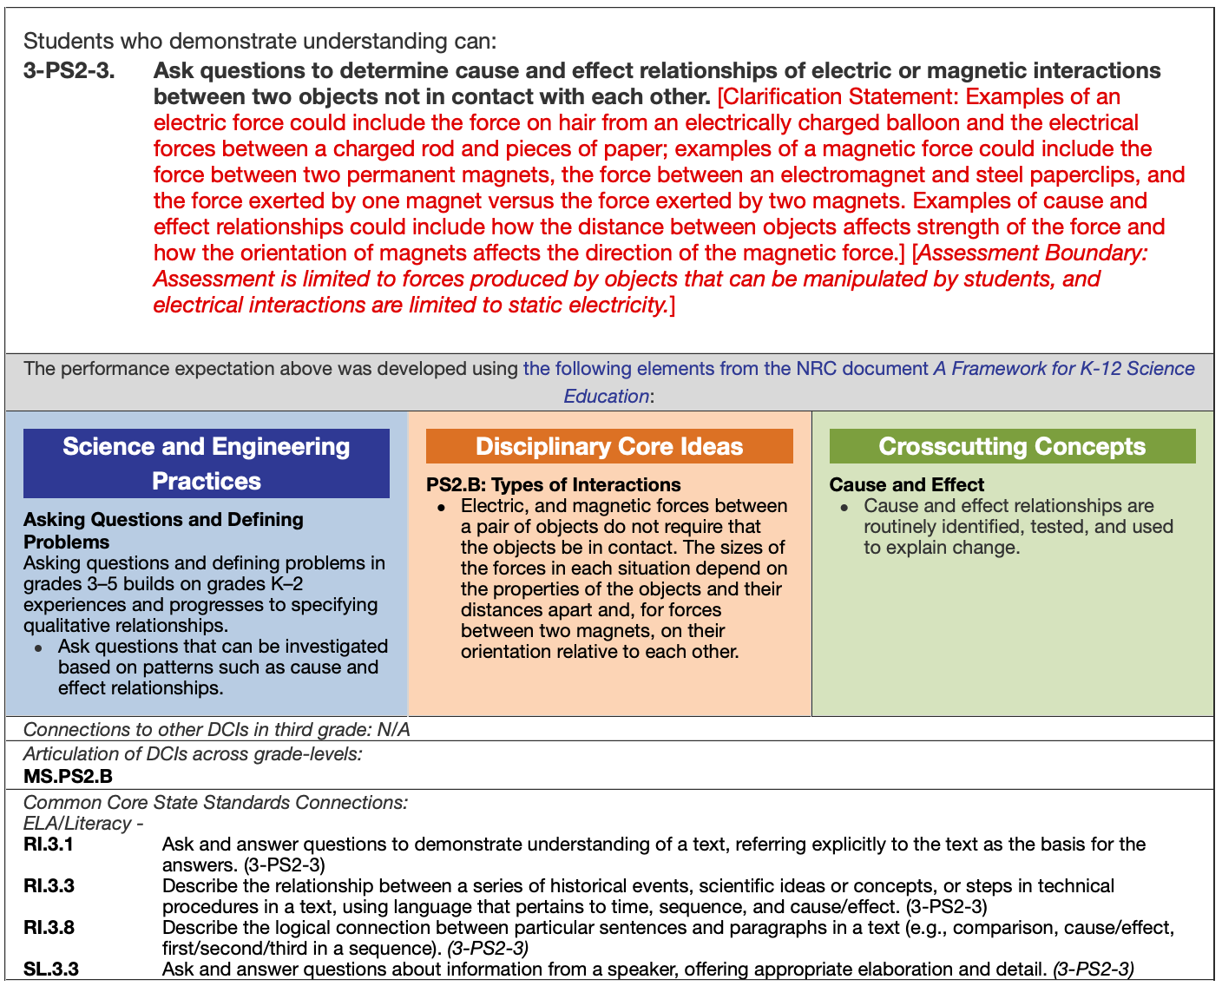
3-PS2-4. Define a simple design problem that can be solved by applying scientific ideas about magnets.*
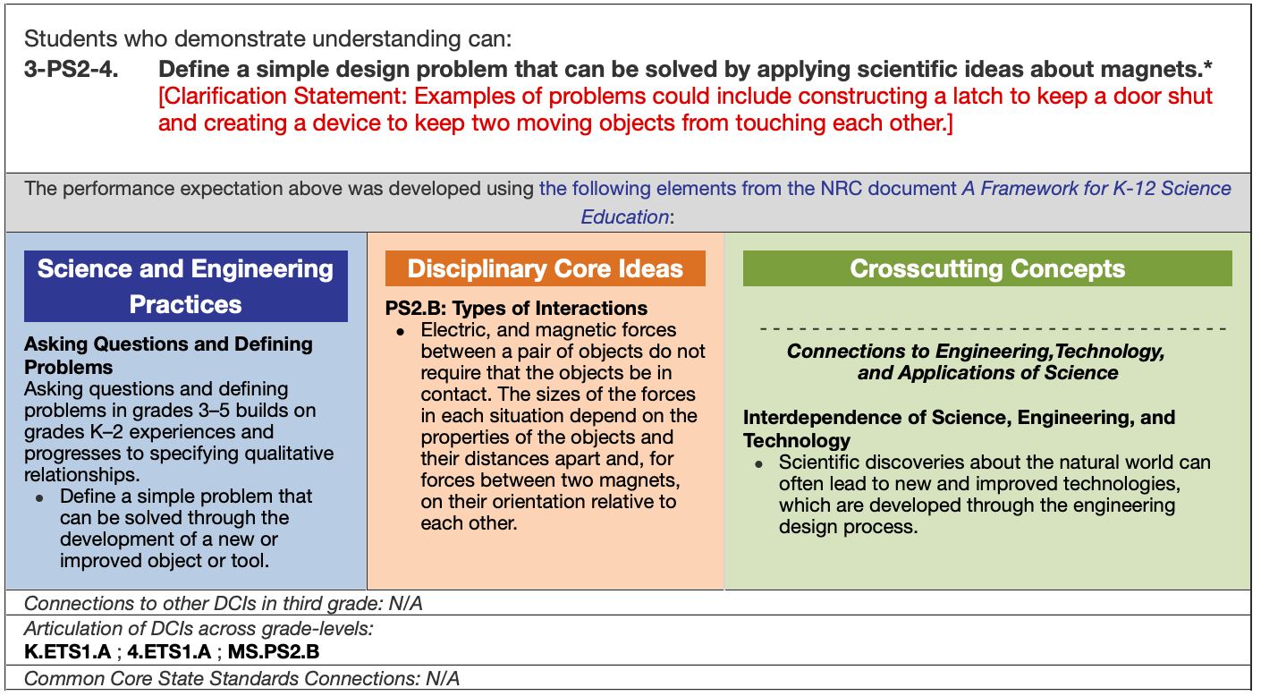
Intended Students | This performance assessment may be used with students in third grade.

Overview and Outline of the Performance ASSESSMENT
Students will watch a video of an oil spill in which several points are covered:

- Scientists conduct research on better and less expensive ways to remove oil from the ocean after an oil spill
- The scientist shown in the video is conducting an experiment to see if he can use a magnet to collect oil together in water so that it can easily be removed from the water.
- In the video, he put oil in a tub of water, then put a powder (magnetite or iron filings) on top of the oil.
- He then used a magnet to pull the powder and oil together moved to the side of the tub.

If your students are not familiar with iron filings and their magnetic properties, it is highly recommended that you also show them the video to help them understand the behavior of the black powder from the video. Consider using the first 20 seconds of this video: https://www.youtube.com/watch?v=H28SMCnGFMY

Suggested Total Time
This assessment has two parts to it. This assessment should take a total of 50 minutes to complete. Specific times for each part are indicated below:

- Part 1 – View Videos and Take Notes (15 minutes)
- Part 2 - Write Responses to Questions (35 minutes)

List of Required Materials
The following materials are required for this assessment:

  - Student Booklets
  - Sufficient blank paper for note taking
  - Pens or pencils for note taking
  - Access to the videos indicated below
  - Video playback equipment necessary for all students to view the videos
  - Videos:
    - https://www.youtube.com/watch?v=lYM324yDH-Q (Oil spill video)
    - https://www.youtube.com/watch?v=H28SMCnGFMY (Iron filings video)

Assessment SetUp
The teacher should ensure that students have sufficient blank paper and pens or pencils for note taking while viewing the videos. The teacher should make sure that all students are able to see the video and hear the audio on the videos.

Detailed Script with Teacher and Student Directions
Directions for teachers are in regular text. Directions to be read to students are in bold.

Students need a Student Booklet and a pen or pencil for use to take notes while reading the article and viewing the videos. When ready to begin, say:

You each should have a Student Booklet. Begin by filling in the information requested on the front cover.

Pause while students complete the requested information. Then say:

Turn to page 2 in your Booklets and read the directions silently as I read them aloud to you.

Pause while students turn to page 2. Then say:

This assessment has two parts to it:

- Part 1 – View Videos and Take Notes (15 minutes)
- Part 2 – Write Responses to Five Questions (35 minutes)

The directions for each part are given in the Student Booklet.

PART 1 – VIEW VIDEOS AND TAKE NOTES (15 MINUTES)
The teacher should ensure that sufficient blank paper and writing utensils are available for student note taking. The teacher should set up the video playback equipment.

If students are not familiar with iron filings and their magnetic properties, show them the video to help them understand the behavior of the black powder from the video. Consider using the first 20 seconds of this video: https://www.youtube.com/watch?v=H28SMCnGFMY.

When ready to show the iron filings video, say:

In order to help you understand the oil spill video that I will show you, I want you to watch this video that illustrates and describes iron filings and their magnetic properties.

Show the video. You may repeat this video one more time if you feel this will help y9ur students better understand iron filings and their magnetic properties.

After showing the video, say:

Do you have any questions about the video I just showed you – about iron filings and their magnetic properties?

Pause and answer any questions that students may have.

If students are familiar with iron filings and their magnetic properties, start by showing them the oil spill video: https://www.youtube.com/watch?v=H28SMCnGFMY.

When ready to move on, say:

Now I will show you the video of the oil spill and the experiment conducted by a scientist to try to remove the oil from the ocean. After you view the oil spill video twice, you will be asked to respond to several questions that are found later in your Student Booklet. You have blank paper and a pen or pencil so you can take notes on what you see in the vide. I will show the video to you twice.

Be sure to watch and listen carefully, so you understand what is shown and described in the video.

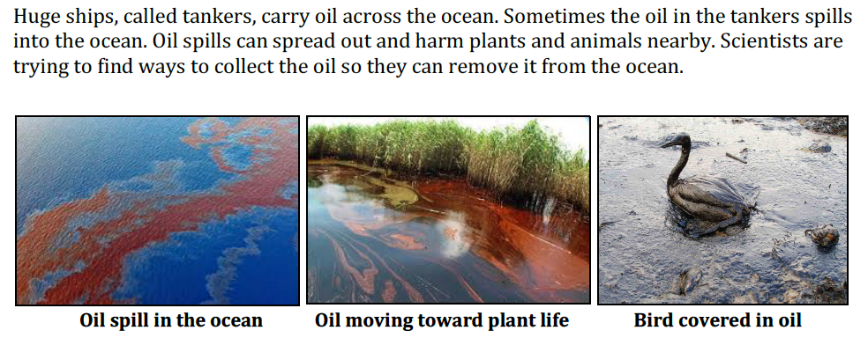

Part 2 – WRITE responseS TO FIVE questions (35 minutes)
These are the five constructed-response questions that students will respond to in their Student Booklets. Response space is condensed in the Teacher Booklet.

When ready to begin, start by saying:

The Teacher Scoring Rubrics that will be used to score your responses to the five questions are found on pages X–Y of your Student Booklet. Review the highest level of performance shown in each I will give you a few minutes to look it over.

Pause for 5 minutes. Then continue by saying:

Now turn to page X in your Student Booklet and follow along while I read the text and questions. I will pause after each question to give you time to respond.

Then, read the script and questions below.

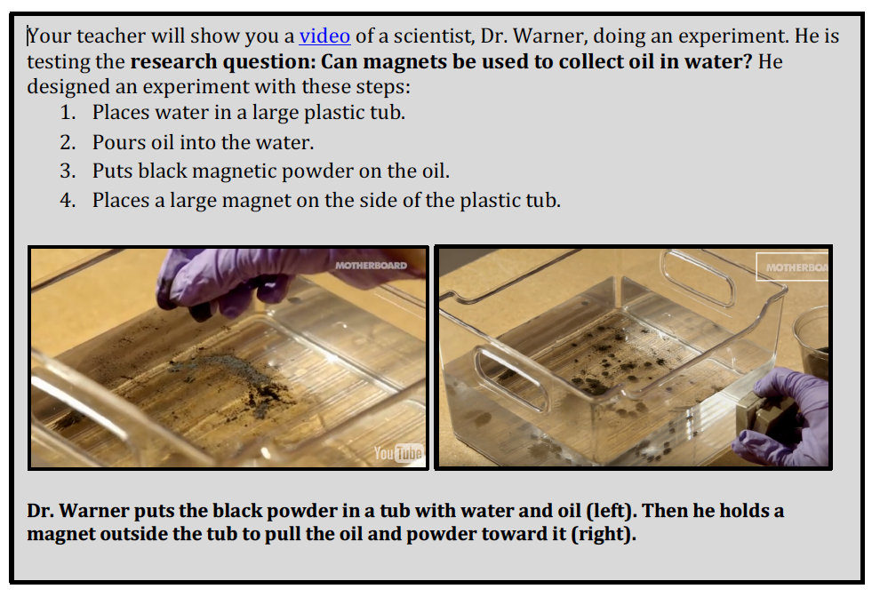

- The first time he tried this experiment, Dr. Warner expected the magnet to pull the oil and the black powder to the side of the plastic tub, but it did not.

One student thought that this was because the magnet must be touching the powder to pull it. Do you agree or disagree? Explain why.

You will have 5 minutes to write your response to this question.

Pause for 5 minutes. Then say:

After making some changes to the design of his experiment, it eventually worked. Dr.
Warner was able to use a magnet to move some of the oil in the water. But he is not sure if
he can use this process to remove all of the oil from the water.
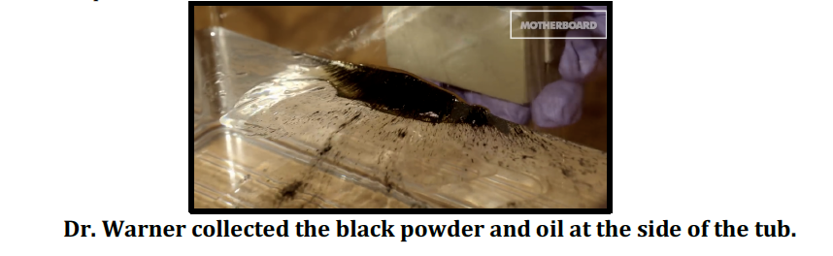
- Write a research question that he could investigate to see how he can use magnets to collect more oil.

- Use what you know about magnets to explain how your question will help Dr. Warner investigate how magnets can be used to collect even more oil.

You will have 8 minutes to write your response to this question.

Pause for 8 minutes. Then say:

Now that Dr. Warner knows the magnet works in his lab, he is ready to test his solution to see if it also works in the ocean.

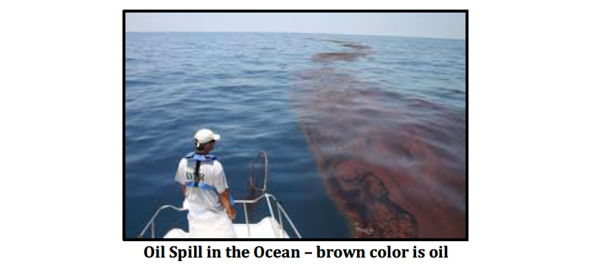
- How could this design challenge affect the magnet’s ability to collect the oil? Explain why.

You will have 5 minutes to write your response to this question.

Pause for 5 minutes. Then say:

- Describe one way he could change the design of his experiment so he will be able to collect the oil even when it is spread out across the water. Explain why you think this change would work.

You will have 5 minutes to write your response to this question.

Pause for 5 minutes. Then say: Time is up. Please close your Student Booklet and leave it on your desk or table.

Teacher Scoring Rubric – Question 1
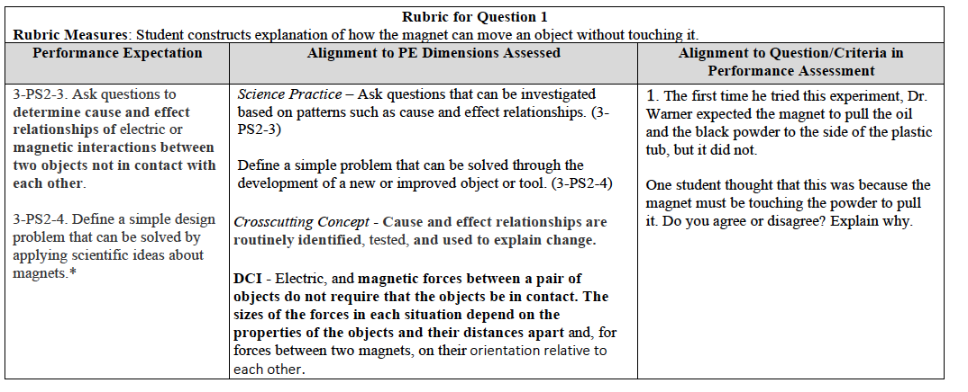
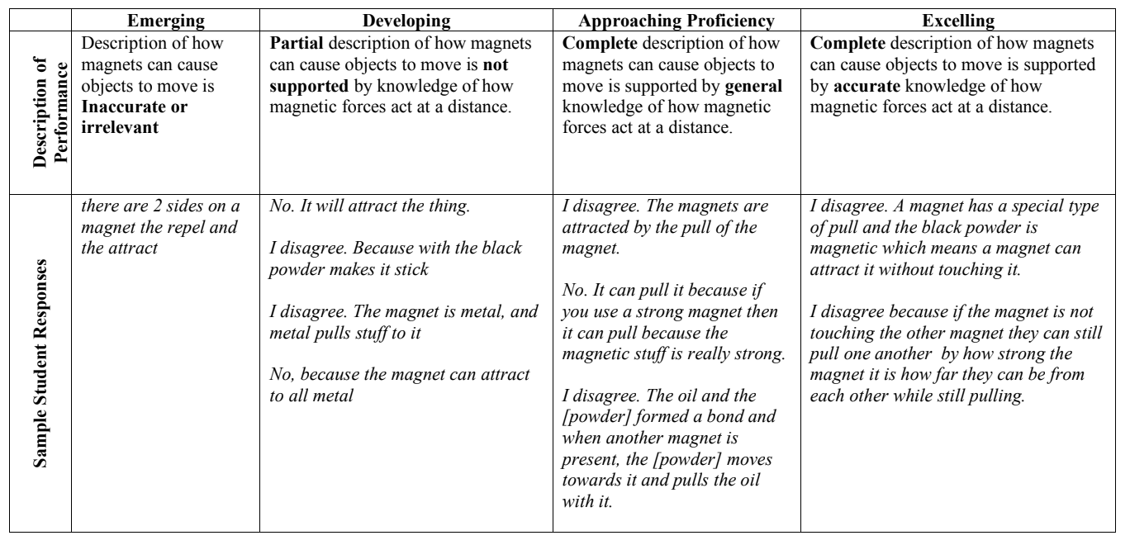

TEACHER SCORING RUBRIC – QUESTION 2 & 3
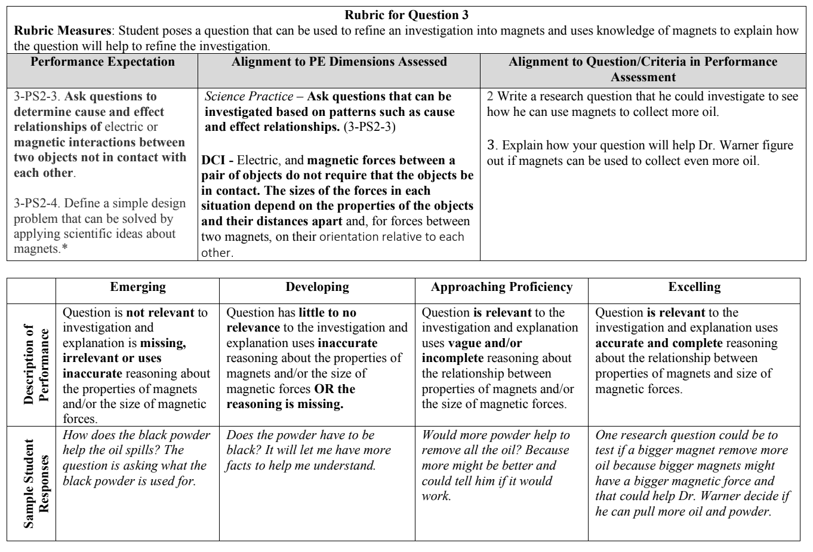

TEACHER SCORING RUBRIC – QUESTION 4
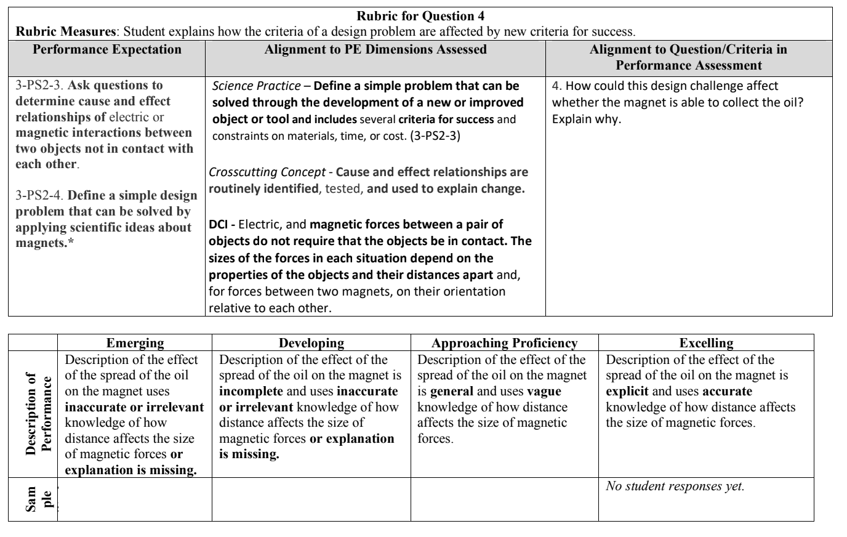

TEACHER SCORING RUBRIC – QUESTION 5
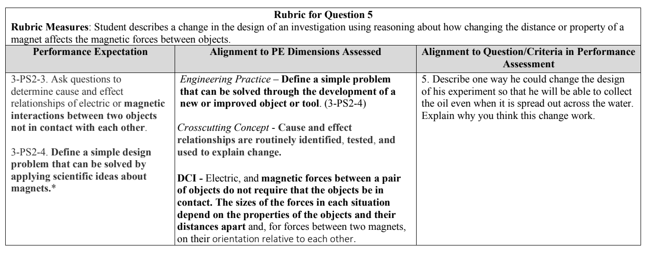

Item Writer Name | Stanford NGSS Assessment Project | Date | October 13, 2019
Team Leader |  | Scientific and Engineering Practices
Editor | Ed Roeber, MAC | Disciplinary Core Idea (s)
Discipline | Science | Crosscutting Concept(s)
Item Type & Number (PT or PE) | Performance Event | Performance Expectation(s) | 3-PS2-3  3-PS2-4
Number of SRs | 0
Number of CRs | 5
Number of Graphics | 6
Grade(s) | 3
Copyrighted Material and Sources (Be Specific)
This assessment was developed by the Stanford NGSS Assessment Project (SNAP) and is
distributed under a Creative Commons CC 4.0 license. This means that you are free to
share and adapt these materials as long as you follow the following terms:

This work is licensed under a Creative Commons Attribution 4.0 License by the Stanford NGSS Assessment Project http://snapgse.stanford.edu/.

Team Leader Comments

Editor Comments
This assessment has been modified to fit the format of other performance assessments created by the Michigan Assessment Consortium. This adaptation of the assessment has not been endorsed nor approved by the Stanford University NGSS Assessment Project.

