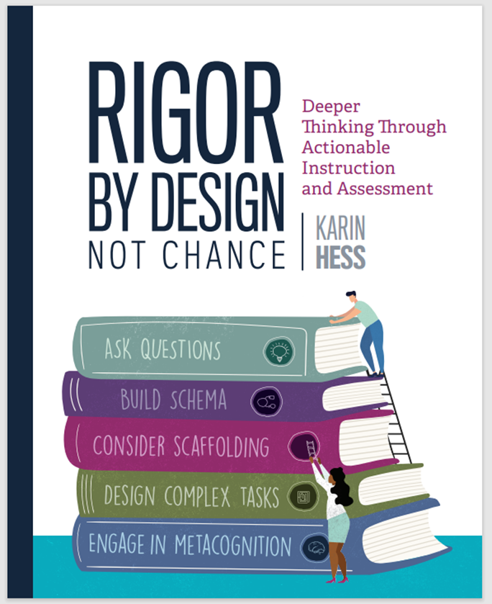 A Book Study Guide for Rigor by Design, Not Chance

Hello Educators,
I’m honored that you/your school has chosen to use my book, Rigor by Design, Not Chance for a book study. Below is a little information about the Guide.

I’ve organized the Guide by first listing the resources that appear at the end of each chapter in the book and the pages where they appear. This will make it easier to access videos and articles related to each of the chapter topics. Next, I included some “Additional Resources” for each chapter that were not originally included when the book was published. The third thing I’ve included are a few suggested reflection/discussion questions for each chapter. These prompts are only a starting point, so feel free to customize how you’d like your professional learning group to share their thinking and build a deeper understanding.

There are several ways to use the resources in the Book Study Guide.
- To see (or clarify) examples of strategies described in the text.
- To deepen or expand your personal knowledge on topics presented in the book.
- To create professional development stations for deeper understanding at your school. For example, participants each choose a different resource to view and then share key ideas with the larger group; or participants join a station group to view and discuss the same resource and how it might be used at their grade level or content area. Stations can be organized by topic, grade level, or content area.
- To create playlists for different professional development purposes.
- To customize chapter-by-chapter discussion guides with selected/added resources.
- To practice using the RbD Walk-Through Observation Tool with selected classroom videos. [I’ve highlighted videos showing teacher-student interactions that could be used for practice observations and promote rich collegial discussions. Many videos automatically take you to similar ones after playing.]

Also, please visit my YouTube Channel or the web page where I’ve posted resources specific to Rigor by Design, Not Chance (with page references where you can read more about it in the text).This page will continue to be updated, so I hope you’ll revisit it often.

Finally, I am always interested in hearing your comments; so, if you’d like to share any thoughts/ideas/questions with me, you can contact me through my website.

I hope you’ll have deep conversations that move your practice forward in meaningful ways.
Best,
Karin

Chapter 1 – Laying the Foundation for Deeper Learning (p.31)

• Assessment for Learning Project
• Hess Cognitive Rigor Matrices: What Rigor Looks Like in Eight Subject Areas Each content domain has its own schema – structures, terms, processes, etc.
• Hess Metacognitive Task Cards and Poster: Six Ways to Uncover Thinking and Deepen
Understanding Print as a poster or use as reflection prompts
• Karin Hess’s Handy Brain Model (video) (10 min) Karin describes how our brain functions as we move from emotional engagement to deeper cognitive engagement
• Karin Hess on Linking Rigor with Research (8 min)
• Lucas Foundation Research Briefs on Project-Based Learning and Deeper Learning
• “Why Does Memorization Reign Supreme?” by U. J. Hansen article and powerful video with student voices about the relevance of deep learning(1 min)

Additional Resources Related to DOK, Actionable Assessment, and Deeper Learning

Brief History of the Hess CRM

Hess Webinar, “Looking for Rigor” (50 min) Introduces the Hess Cognitive Rigor Matrix, 7 Common Misconceptions about rigor, and a few strategies that promote deeper thinking. (Produced by Mentoring Minds (2021)

Marc Chun - Diving into Deeper Learning (16:30 min) Defines deep learning, explains near-far transfer, strategies for solving unexpected/novel problems (“crazy carrots”).
- Dylan Wiliam - Assessment for Learning (9 min) Dylan Wiliam reviews assessment for learning, shares research reports synthesizing the results of research projects on feedback, assessment, and assessment for learning. Can you make any connections with the Actionable Assessment Cycle?
- Utah’s Formative Assessment Process Toolkit
- Beyond Tradition: Transforming Education for a Future-Ready Generation with Yong Zhao (48 min – I suggest watching the first minute, and then discuss your “WHY”)
- Personalized Learning Plans (12 min) PLPs support deeper learning of academics through goal setting, planning, and carrying through on an area of interest.
- Deeper Learning of Core Competencies (12 min) Engineering and science teams work on interdisciplinary projects, applying academics and personalized learning skills.
- Authentic Student Voice Example – Out of the Margins (6 min) Students share what they really want to learn about and teach others about history.
Chapter 1 - Things to Ponder…

What insights or questions do you have about learning, productive struggle, and the way our brains work? (pp. 13-17)

How would you describe “actionable assessment” or the Actionable Assessment Cycle to a colleague? (pp. 28-30) How does it relate to lesson and assessment planning?

What do you believe and value regarding deeper learning/rigor for every student?

What are some of the opportunities & challenges if colleagues share a common vision of deep learning?

Chapter 2 – Ask Probing Questions (pp. 51 – 52)

• “The 20-Minute Peer Feedback System”
www.spencerauthor.com/the-20-minute-peer-feedback-system
• “Better Questions in the Classroom Lead Students to Think Harder—And Learn Deeper” by
S. Bradbury and R. Berlin www.edsurge.com/news/2021-06-28-better-questions-in-the-classroom-lead-students-to-think-harder-and-learn-deeper
• Facing History and Ourselves Teaching (strategies, resources, and videos) www.facinghistory.org
– Barometer: Taking a Stand on Controversial Issues www.facinghistory.org/resource-library/teaching-strategies/barometer-taking-stand-controversial-issues
– Taking Barometer Online www.facinghistory.org/resource-library/video/taking-barometer-online (3:32 min) Describes the Barometer activity if used in virtual settings.
• Five Ways to Use Word Clouds in the Classroom by Monica Burns
www.edutopia.org/article/5-ways-use-word-clouds-classroom
• How to Write Driving Questions for Project-Based Learning (15 min) An April Smith tutorial on how to create driving questions. You can also download her manual.
• Media Images Library compiled by media literacy consultant Frank Baker
www.middleweb.com/author/frankwbaker
• PBS Learning Media www.vermont.pbslearningmedia.org
• Right Question Institute www.rightquestion.org
• Scaffolding Discussion Skills with a Socratic Circle (3:37 min) Planning strategies for academic discussions in a high school social studies classroom. Students track the contributions of peers.
• Smithsonian Institute Archives https://siarchives.si.edu/what-we-do/photograph-and-image-collections
• Wonder Walls www.doinggoodtogether.org/bhf/create-a-wonder-wall
• Would You Rather Math Teacher-developed visual images offering choices to students and ask for mathematical reasoning.

Additional Questioning Strategies & Resources
- Chat Stations Discussion Tool (5:31 min.) A discussion framework to liven up instructional routine in any content area. Easy to set up directions.
- Rethinking Wait Time: Four Places to Pause During Number Talks (Math Monday) Blog post with reminders of when to use wait time.
- Math Partners (1 min) Elementary students solve, discuss, teach it to the class.
- The Art of Questioning (5 min) Using “stepping stones” to get to deeper meaning of texts.
- The Depth & Complexity Framework (5 min.) Overview Depth and Complexity: Everything You Need to Know (byrdseed.com); use with graphic organizers. Teachers can apply their understanding by revising some of their unit questions and giving each other feedback.
- Socratic Seminars: Choose and view a video and discuss how you might use it in your classroom. The purpose is to extend learning!
- Grade 2 Socratic Seminar (8:38 min) Teacher uses the Socratic Seminar strategy in her second-grade classroom. Practice speaking-listening with Buddy Reading prep; review management strategies (yarn circle), rules, equity sticks; large group discussion – How to get started - use sentence frames, etc.
- Grade 4 Socratic Seminar (7 min.) A fourth-grade teacher uses a line of questioning in a structured, text-based discussion to help students recognize important elements and themes in a piece of graphic art.
- Upper Elementary Socratic Seminar (9 min) Teacher prep (text choices – to elicit big ideas), purpose, and teaching students about types of question- closed, open, and big ideas.
- Grade 7 Socratic Seminar (6 min.) Step inside a 7th grade ELA classroom to see how students are approaching a Socratic Seminar lesson, taught by Kyrene School District teacher, Jill Malina. Locating text evidence – explains “pilots and 2 wingmen” discussion structure.
- HS Socratic Seminar (5 min) Learning to support claims and counter claims.
- Lesson Examples for Planning Socratic Seminars | Read Write Think

Chapter 2 - Things to Ponder…

What are we doing effectively right now with our approach to asking probing questions that go deeper?

How might we improve our practice?

Chapter 3 – Build Schemas (p. 69)

• Edutopia Videos - Search hundreds of video clips for topics interest
• How to Sketchnote: A Step-by-Step Manual for Teachers and Students by Sylvia Duckworth
• Jigsaws: A Strategy for Understanding Texts (2 min) The teacher uses a jigsaw strategy to help students understand text structure.
• Now Spark Creativity Website with useful blog posts and ELA strategies
• Pattern Folders—A Literary Analysis Tool (3 min) Strategy to help students connect details + big ideas
• Sketchnotes Strategies
• Sketchnotes: Supporting Research Related resources and research
• The Writing Recipe: Essay Structure for ELLs (7 min) Teacher models use of manipulatives (5 index cards) to illustrate the essay schema.
• Vermont Writing Collaborative Painted essay and ELA resources
- 6 Ways to Merge Literacy With Mathematics Strategies to help students make connections

Chapter 3 - Things to Ponder…

What does building schema mean to you? Sketchnote to show your thinking.

What strategies could be used to build schema and deepen student learning in your classroom?

Chapter 4 – Consider Strategic Scaffolding (pp. 89 – 90)

• Carousel Activity: Rotating Through Geometry Stations (5 min) – Activity encouraging peer feedback and reasoning that can be adapted at any grade level or content area
• Clarifying ‘Messy’ Objectives (6 min) Teacher models the strategy
• Color-Coding: The Differentiation Strategy You Never Knew You Needed by Allyson Caudill
• Designing Socratic Seminars to Ensure That All Students Can Participate by John Spencer
• Encouraging Academic Conversations with Talk Moves (4 min) Middle school teacher uses sentence frames to encourage discourse
• Hint Cards (2 min) Middle school teacher describes strategy to develop more independent learners
• Improving Participation with Talk Moves (2 min) Fourth grade students use 4 talk moves.
• Literal (minimal monthly per-student charge to subscribe) – Full texts are chunked like text messages
• Hess TBEAR Template - With an ELA and math example; can be used to support planning for writing/discussion or to support vocabulary development
• Thinking Verbs: Improve Academic Language with Thinking Verbs (5:25 min) Supporting academic language school wide for ELL students
• Understanding Language, Supporting ELLs in Math
• Universal Design for Learning/UDL (CAST)
• WIDA Consortium’s English Language Development Standards
• Wonderopolis - Resource library for students to explore topics of interest using their questions.

Additional Scaffolding & Differentiation Resources
- Read Karin’s blog post, To Scaffold or not to Scaffold.
- Teaching the Long-Term Value of Annotation Teaching Annotation in High School | Edutopia - Help students learn how to annotate with 4 steps.
- Chunking Text Example
- Card Pyramid – Strategy for summarizing a text using index cards or template
- How drawing can lead to deeper understanding ( 1:30 min) Research supporting sketchnoting
- Differentiating with Learning Menus (5 min) Middle school social studies teacher creates a 3-tiered menu of choices for students to select and “test” out of before moving to the next level.
- Giving students Options – Menus (2 min) Middle school math teacher creates a 3-tiered menu of choices for students to select and “test out of“ before moving to the next level.
- Differentiation – Stations (5:15min) Rotation stations allow first grade students to learn in a range of modalities, while making differentiation manageable for one teacher.
- Differentiating Instruction – Lesson Planning (3:24 min) How to manage using extension strategies; modify how students respond with sentence starters
- Stations in Secondary Classrooms (4:32 min) Sarah Swartz teaches middle school in Alaska. A tutorial on how she uses classroom stations.
- Hess Quick Tips for Differentiation - A planning tool to create menus.
- Differentiation - Sample Menus grades 3-5 – Sample menu prompts using a text
- Scaffolding - Response cards (1 min) Using sentence stems – try using mine (pp. 81, 140)
- Scaffolding - Developing Executive Functions (3:49 min) Explicitly modeling the process of prioritizing tasks builds students’ ability to organize and manage their time. “Eat your frog first.”

Scaffolding - Teaching Students to Prove Their Mathematical Thinking (6:17 min) Third graders learn how to solve math problems through cognitive guided instruction: grapple with problems, engage in discourse with peers, work to prove their mathematical thinking to the group. Strategies: chart the strategies, use probing questions and discourse.

Scaffolding - Ranking Baseball Players (6 min) Scaffolding DOK 3-4 tasks: teacher selects data sets; pairs work; software to graph/analyze data; defend claim. Differentiate: extend, own, go deeper.

Chapter 4 - Things to Ponder…

Many educators confuse scaffolding with differentiation. What new insights are you gaining?

How – or when- could you effectively use scaffolding?

How – or when- could you effectively use differentiation?

Chapter 5 – Design Complex Tasks (pp. 124 – 126)

• BEST Toolkits www.best-future.org/resources
• BEST K–12 Collaboration Rubrics www.karin-hess.com/archived-postings
• Choice Boards for English Language Arts NC has developed choice boards in ELA for all grade levels
• Choice Board Templates for Google Slides or PowerPoint https://slidesmania.com/tag/choice-boards
- Defined Learning: High-Quality Project-Based Learning for All www.definedlearning.com
• Exemplars Performance tasks in mathematics problem solving and science investigation
• Facing History and Ourselves Teaching (strategies, resources, videos) www.facinghistory.org
• Free Technology for Teachers by Richard Byrne www.freetech4teachers.com
• Genius Hour, Design Thinking, and More by A. J. Juliani www.ajjuliani.com/blog
• Hess Assessment Development Tools www.karin-hess.com/formative-and-performance-assessments
• Integrating Social-Emotional Learning with Project-Based Learning by Mike Kaechele
www.michaelkaechele.com
• KQED Learn Youth Media Challenges www.kqed.org/education/collection/youth-media-challenges
• PBL Works www.pblworks.org
• PBL Works for Remote Learning www.pblworks.org/pbl-remote-learning
• Project-Based Learning, Genius Hour, and Distance Learning by John Spencer www.spencerauthor.com
• Project-Based Learning Planning Guide (for elementary grades)
www.performingeducation.com/planningguide
• Project-Based Learning and Powerful Instructional Practices www.sreb.org/powerful-instructional-practices Examples in many content areas
• Project-Based Learning Projects and Teaching Strategies by Todd Stanley www.thegiftedguy.com/resources
• Projects and PBL: What’s the Difference? (2:31 min) www.youtube.com/watch?v=dhwuQU2-g5g
• The Power of Performance Assessments: Oakland Unifi ed’s Graduate Capstone Project (5:27 min) A yearlong Graduate Capstone Project provides opportunities for students to research, analyze, and become experts in a chosen topic.
• Stanford NGSS Assessment Design and Analysis Resources
https://scienceeducation.stanford.edu/snap/ngss-assessment-design-and-analysis-resources
• Stanford Instructionally Embedded Assessments
https://scienceeducation.stanford.edu/assessment/instructionally-embedded-assessments
• Starting Your Podcast: A Guide for Students
www.npr.org/2018/11/15/662070097/starting-your-podcast-a-guide-for-students
• Tools to Help Students Base Opinions in Fact by Curtis Chandler
www.middleweb.com/44136/tools-to-help-students-base-opinions-in-fact
• We Teach NYC www.weteachnyc.org Sample performance tasks with rubrics and annotated work
• What’s the Story? The Vermont Young People Social Action Team (some student videos posted) www.whatsthestory.middcreate.net/vermont
- Added What's the Story? (Links to teaching resources); Introductory Lesson; and Process Steps- Use to share a personal perspective or reflection on "life" events
- Six-Word Memoirs Six-Word Memoirs – One Life, Six Words. What's Yours? (sixwordmemoirs.com)
Chapter 5 - Things to Ponder…

New insights or questions about ways to create or use complex tasks?

In what ways can student input and decision making make learning and performance-based assessments meaningful for students?

Complex tasks take time. Are they worth it?

Chapter 6 – Engage Students in Metacognition & Reflection
(pp. 147 – 148)

• The 20-Minute Peer Feedback System www.spencerauthor.com/the-20-minute-peer-feedback-system
• BEST Toolkits www.best-future.org/resources
• Facing History and Ourselves: Reflective Journals
www.facinghistory.org/ela/coming-age/unit-planning-toolkit/teach-facing-history-journal-prompts
• My Favorite No: Learning from Mistakes (6 min) https://learn.teachingchannel.com/video/class-warm-up-routine Teacher questioning applies multiple scaffolding strategies and DOK levels.
• Peer Feedback Using Rubric Success Criteria (10 min) www.karin-hess.com/learning-progressions Peers use rubric levels and evidence to provide feedback. (Teachers College Reading Writing Project)
• Portfolio Defense Overview www.envisionlearning.org/portfolio-defense
- Show & Tell: New Thinking About Student Engagement (6 min)
www.ascd.org/el/articles/show-and-tell-a-video-column-new-thinking-about-student-engagement
• SPUR Assessment Process Overview www.thecrtc.org/spur-assessment
• SPUR Sample Student-Led Conferences Video (15 min) www.youtube.com/watch?v=ueRcBg8uYS8 CTE students [3-minute conferences] where they share work and set goals.
• Student-Led Conferences: Kindergarten (4:36 min) www.youtube.com/watch?v=dmIReiqI1ec A student meets with her parents to share what she has learned.
• Student-Led Conferences: Kindergarten (6 min) www.youtube.com/watch?v=xvsHi1sZf9U Whole class simultaneous conferencing, moving from one station to another. Parents talk about experiencing the conference with their child.
• Student-Led Conferences - 3 Podcasts www.hthunboxed.org/tag/slc-miniseries
• Student-Led Conferences: A How-to Guide (guide + 2 min video)
www.hthunboxed.org/unboxed_posts/student-led-conferences-a-how-to-guide
• Virtual Portfolio Defense Toolkit Developed by Envision Learning Partners
www.hewlett.org/wp-content/uploads/2020/10/ELPVirtualDefenseToolkitcc3.0.pdf

Additional Metacognition and Reflection Resources

- Student Led Conference Middle School Example (5 min) Student uses a conferencing guide, explains her grade, and responds to her parent’s questions.
- Student-led Conferences Build Agency (3:43 min) When students lead meetings with their parents and teachers, they gain a voice in their education, developing goal-setting and metacognition.
- Student-led Conferences (5 min) Putting students in the driver's seat of their parent-teacher conferences creates opportunities for reflection, engagement, and agency. Prework includes organizing materials, setting goals, and writing an essay about strengths and challenges.
- Student Voice – Senior Talks (3:49 min) High school seniors build confidence by documenting their growth and learning in a speech presented to their families and the school community.
- Why a NH School Decided to Implement Student-Led Conferences (1) In Charge: Student-led Conferences - YouTube (13 min)
- Socratic Seminar Planning Guide & Sample Self-Reflection Questions Socratic Seminar Teaching Strategy | Facing History & Ourselves
- Peer Feedback - Bean critique 60-Second Strategy: Bean Critique - YouTube – Students put 2 beans into cups after reviewing peers’ work.
- Questioning Skills Spark Self-Directed Learning Good Questioning Skills Spark Self-Directed Learning (middleweb.com)
- Austin’s Butterfly Austin's Butterfly: Models, Critique, and Descriptive Feedback - YouTube (6:33 min.) Master teacher, Ron Berger, models how peers can give feedback.
- Ron Berger – 3 Rules For Critique: Be kind, Be specific, Be helpful Ron Berger - Rules For Critique - YouTube (2 min.) Master teacher, Ron Berger, discusses how to give feedback. A sample peer feedback sheet might look like the one below.

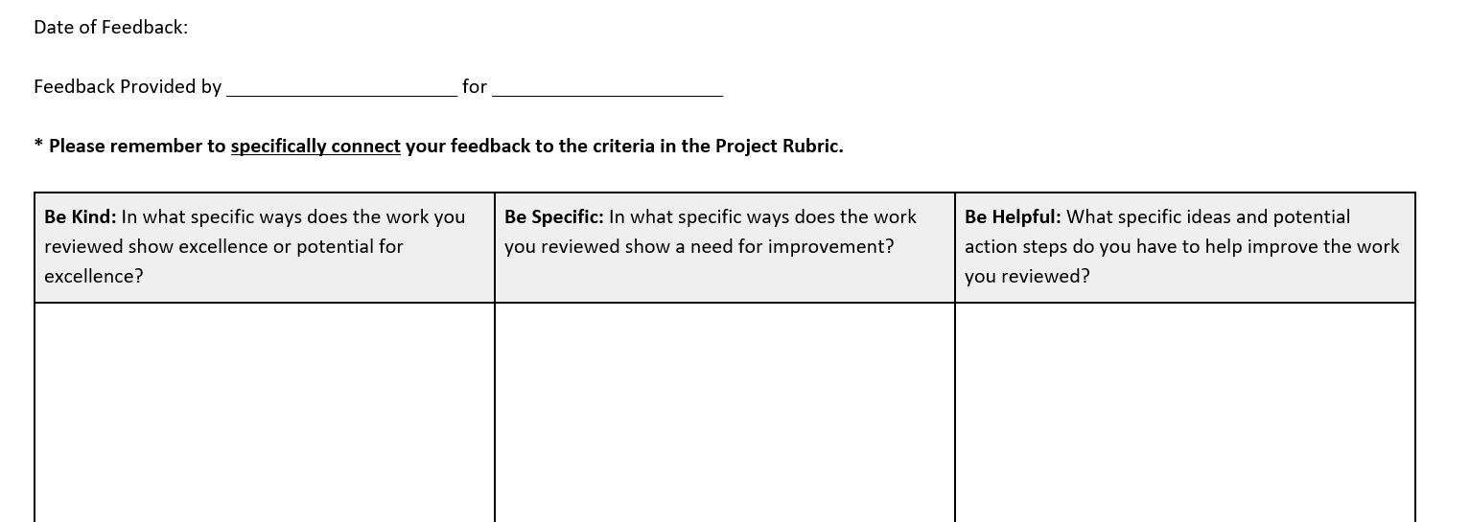

Chapter 6 - Things to Ponder…
New insights or questions about promoting student reflection, agency, or voice?

What are some benefits of student-led conferences? How could they be implemented in your school or classroom?

What might be a good starting point to integrate meaningful metacognitive strategies?

Chapter 7 – Putting it All Together (p. 165)

• Better Lesson Teacher-Designed Lessons Thousands of lesson ideas to explore or adapt.
• CogKnow Software for Unit Planning Design lessons using this software that integrates standards with the Hess Cognitive Rigor Matrices descriptors
• Hess Lesson/Unit/Project Planning Template with DOK Levels – Blank Template for planning or analyzing lessons or units of study
• Hess Looking for Rigor Walk-Through Observation Tool - Annotated [examples from Rigor by Design]

Additional Resources for Planning and Observation
- Hess Looking for Rigor Walk-Through Observation Tool - Blank interactive template for note taking, observation practice, and feedback
- Using the Actionable Assessment Cycle to Build Lessons/Units – A planning tool
- Learning Walks (5:15 min) Describes how to engage in a learning walk
- A Simple Tool to Help With Lesson Planning and Post-Lesson Reflection A Checklist for Lesson Planning | Edutopia

Chapter 7 - Things to Ponder…
New insights or questions?

How might you use or adapt any of the planning or observation tools explored?

