Module 6
Examples of Extended Standards
From the Idaho State Department of Education – The following are examples of expanded standards taken from a larger set for students with significant disabilities.

Mathematics Example – Grade 3 (Three Levels of Access)

More Complex ---------------------------------------------------------------------- Less Complex
Extended Content Objectives | Access Level  3 | Access Level  2 | Access Level  1
3 M 1.1.3 A Sort coins and one-dollar bill by identity and value. | The student sorts by value (Given an example of a nickel, the student identifies all other nickels.). | The student sorts by type (The student places together all pennies, nickels, and dimes.). | When presented with a penny and another object, the student chooses the penny.

Reading Example – Grade 6 (Four Levels of Access)

More Complex ------------------------------------------------------------------------- Less Complex
Extended Content Objectives | Access Level  4 | Access Level 3 | Access Level  2 | Access Level  1
6.LA.2.2.3 A Identify facts & details from expository text using picture or object clues to retell. | The student independently answers who, what, when, and where questions about a reading. | The student retells the events of a simple (3-5 sentence) reading. | The student describes what happened first, next, and last (beginning, middle, & end) in a reading. | The student listens to a reading and points to a picture or object to identify what came first in the reading.

Science Example – Grades 9 and 10 (Four Levels of Access)

More Complex --------------------------------------------------------------------------- Less Complex
Extended Content Objectives | Access Level 4 | Access Level 3 | Access Level 2 | Access Level 1
9-10.B.1.2.1.A  10th Grade | Make a model representing the system. | Compare and contrast data collected, giving explanation about findings.  Student will be able to discuss similarities and differences in data collected and why. | Organize information collected and make a predication.  Student is able to record the data on a simple paper and pencil or electronic graph* related to an observation and make a predication. | Collect data over a period of time and present information.  Student is able to record the data on a simple paper and pencil or electronic graph* related to an observation.

From the Massachusetts Department of Elementary and Secondary Education

Mathematics Number Sense 1.1 Number Sense and Numeration
Pre-K - 4 Learning Standard Essence of the Standard
Students engage in problem solving
communicating, reasoning, and connecting to:
• Construct number meaning by using • Counting
manipulatives and other physical materials • Grouping
to represent the real world. • Moving from whole to part
•Demonstrate an understanding of our • Moving from concrete to abstract
numeration system by relating counting,
grouping, and place value.
•Interpret the multiple uses of numbers by
taking real-world situations and translating
them into numerical statements.
Entry level <------------------------------------------------------------> More Complex
The student will: The student will: The student will:
• Sort and classify. • Group by 5s, 10s or 100s. • Identify numerals by
• Group objects according to • Count in a variety of settings place value in numbers (e.g., what
attributes • Group objects by specific is in the 10s column in 143?)
• Demonstrate one-to-one multiples • Count on/back from any number correspondence.
• Distinguish between same/different,
more/less, bigger/smaller,
shorter/longer, and other simple
number meaning comparisons.
Instructional Ideas
Using a variety of objects, the student will count and sort objects by specific attributes, such as color or size. Use a group of mixed objects and have the student sort the objects by color into two piles.
Have students think of other ways to sort a group of objects, and then classify the objects in those ways. Compare classified groupings of objects in terms of more or less, or the number of objects, so that they learn which group has more, which has less, or if they have the same number.
Have students practice counting the numbers one to ten, as well as one-to-one correspondence, either by showing numbers on fingers and having a student match each finger with an object, having students match blanks on a piece of paper with
objects, or actually pair objects.
Also, have the students count objects by ones, twos, threes, and so on.

Assessment Materials
• 15 commonly available objects in the classroom, including: blocks, plastic colored disks, pencils, coins, socks, pens, leafs, small toys such as cars. The objects should be several different sizes, lengths, and several colors.

• Table large enough to hold the materials, with two chairs.
Assessment Setup

• Arrange the materials in a random manner on the table. Seat the student in front of the objects.
Assessment Strategies
1. Ask the student to sort the objects according to one characteristic, such as size. If the student can do this, then have the student sort the objects by another characteristic, such as color, length, width, texture.
2. Construct two sets of objects, one with several more objects than the other. Then ask the student which group has more objects in it.

3. Place two objects in front of the student and ask the student to indicate which object is shorter or longer, or larger or smaller.

4. Have the student show one-to-one correspondence by placing an object at the end of three fingers held in front of the student on the table. Alternatively, the student could place one object over the outline of the object on a form-card.

5. Ask the student to count from one to ten. This could be verbally, the recognition of the numerals in order, or other way of indicating the sequence of numerals.

6. Line up the objects and ask the student to count the objects singly, such as “one, two, three, four....” If the student can do this, ask the student to count the objects in pairs, such as “two, four, six....”

7. Have the student think of a way to sort the objects. Have the student indicate one way the objects could be sorted. Then the student should sort the objects in that manner.

Assessment Questions

• Is the student able to count, and if so, by ones, twos, and so forth?

• Can the student describe characteristics of objects, such as size, shape or color?

• Can the student tell relative attributes, such as same/different; larger/smaller; longer/shorter; more/less?

• Is the student able to show one-to-one correspondence in setting table?

• Is the student able to show one-to-one correspondence in setting table, giving each student a snack, or other classroom tasks?

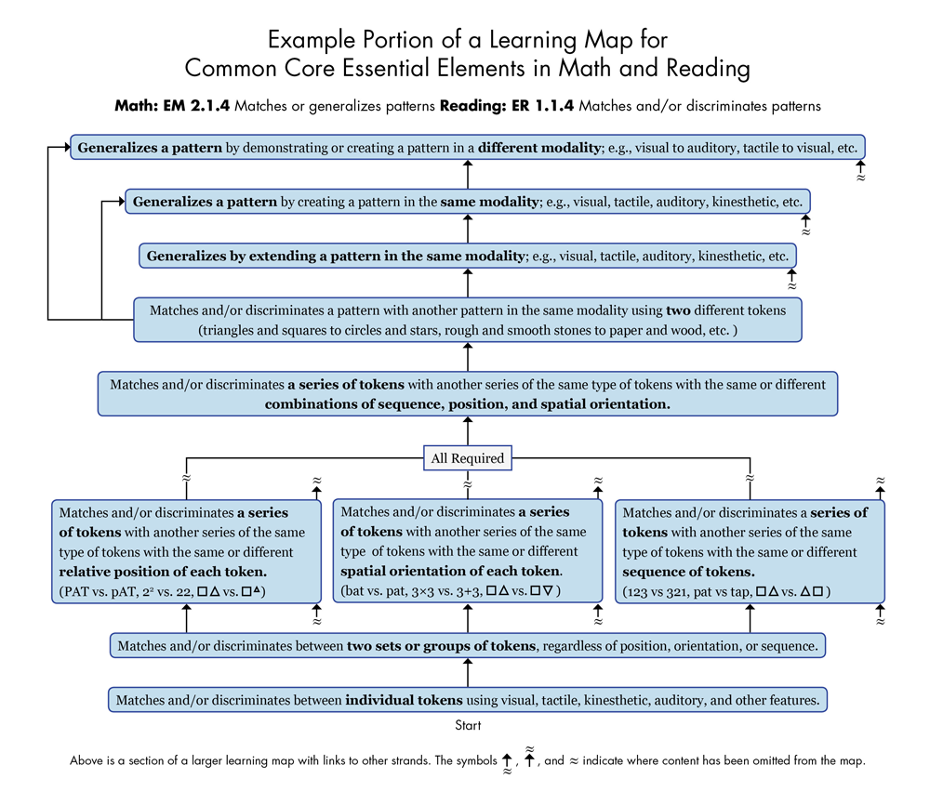

Example provided by the Dynamic Learning Maps Alternate Assessment System Consortium, University of Kansas, 2011.

