Test
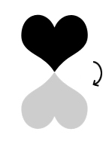
A
- The shape below can be transformed from its original position to its final position in one rotation about point A. Which rotation listed below shows this?

- 90° rotation
- 180° rotation
- 270° rotation
- 360° rotation

- If a cube has an edge of 4, what is its volume?
- 8 cm³
- 12 cm³
- 16 cm³
64 cm³

- Which number equals (‾2)⁰?
- 0 B -1 C 1 D -1/2
- Due to an increase in the cost of building materials, the cost of remodeling a building is now 28% more than its original cost. If
$5,438 was the original cost, what is the new cost, to the nearest dollar?

$15,226 $6,961
$1,523 $5,466

