Mathematics Assessment Prototype
International Baccalaureate Program

Mathematics
Performance Assessment

Performance Event M.6.3.1
Area

Grade 6

Teacher Booklet
Teacher Directions
Student Directions
Teacher Scoring Rubric
Student Questions

Acknowledgements

International Baccalaureate Program

This item has been reformatted by the Michigan Assessment Consortium, 2020, for demonstration purposes in professional learning about performance assessment. This item is presently being used with students in I.B. programs and therefore should not be circulated or used without expressed permission.

Mathematics Standards Assessed
Content Standard | Math 6 Claim 3
Performance Expectation(s)
Intended Students | This performance assessment may be used with students in sixth graders.

Overview and Outline of the Performance ASSESSMENT
Students will be asked to calculate the area of a field and then determine if an individual who wishes to plant grass has sufficient seed in order to seed the entire area. Students are asked for their reasoning, supporting their conjecture by using formulas, pictures and/or properties that will support their conjectures. Finally, students are asked to write a conclusion to the entire problem connecting their conjecture(s) to their reasoning, making sure to use math vocabulary.

Suggested Total Time
This assessment has two parts to it. It should take a total of 25 minutes for students to complete.

- Part 1 – Make a Conjecture and Show Your Reasoning (10 minutes)
- Part 2 – Write a Conclusion, Connecting Reasoning to Conjecture (15 minutes)

List of Required Materials
The following materials are required for this assessment:

  - Student Booklet
  - Sufficient blank paper
  - Pens or pencils for note taking

Assessment SetUp
The teacher should ensure that students have sufficient blank paper and pens or pencils for student calculations, note taking, and drafting written responses. Students should have access to a calculator with which they are familiar.

Detailed Script with Teacher and Student Directions
Directions for teachers are in regular text. Directions to be read to students are in bold.

Students need a Student Booklet, a pen or pencil, and a calculator. When ready to begin, say:

You each should have a Student Booklet. Begin by filling in the information requested on the front cover.

Pause while students complete the requested information. Then say:

Turn to page 2 in your Booklets and read the directions silently as I read them aloud to you.

Pause while students turn to page 2. Then say:

This assessment has two parts to it:

- Part 1 – Make a Conjecture and Show Your Reasoning (15 minutes)
- Part 2 – Write a Conclusion, Connecting Reasoning to Conjecture (10 minutes)

The directions for each part are given in the Student Booklet.

PART 1 – MAKE A CONJECTURE AND SHOW YOUR REASONING (10 MINUTES)
Students should have blank paper and a pen or pencil available to them. When ready to begin, say:

You will be asked to read and respond to three questions in this assessment. The Teacher Scoring Rubric that will be used to evaluate your responses is shown on page X of your Student Booklet.

Teacher Scoring Rubric
Points | Aspect of the Assessment | Possible Responses
1 | Make a conjecture | Correct or incorrect conjecture
1 | Use mathematics vocabulary | Communicate precisely, using mathematics vocabulary appropriately
2 | Provide evidence to support your conjecture | Formulas, pictures, and properties
2 | Clear and complete mathematical reasoning | Connect evidence to the problem

I will give you a couple of minutes to look it over before we begin. You may refer to this rubric as you answer the three questions in this assessment.

Pause for 2-3 minutes. Then say:

Read the first question to yourself as I read it out loud.

1. There is a new park being built in Jamar’s community. They are planting grass in a new field and have enough grass seed to cover 225 square yards. You will have 10 minutes to respond to the two questions.

- Make a conjecture stating if Jamar’s community has enough grass seed to cover the entire field. Show your reasoning using formulas, pictures and/or properties that will support your conjecture.

_____________________________________________________________________________________

_____________________________________________________________________________________

_____________________________________________________________________________________

_____________________________________________________________________________________

When 10 minutes are up, say:

Time is up. Now we will go on to Part 2 in your Student Booklet.

PART 2 – WRITE A CONCLUSION, CONNECTING REASONING TO CONJECTURE
(15 MINUTES)
Students should have blank paper and a pen or pencil available to them. When ready to begin, say:

Read the second question to yourself as I read it out loud. It is:

3. Write a conclusion to the entire problem connecting your conjecture to your reasoning. You must include math vocabulary.

_________________________________________________________________________________

_________________________________________________________________________________

_________________________________________________________________________________

_________________________________________________________________________________

_________________________________________________________________________________

_________________________________________________________________________________

_________________________________________________________________________________

_________________________________________________________________________________

After 15 minutes (or when students have finished), say:

Time is up. Please close your Student Booklets and leave them on your desk or table.

Answer Key

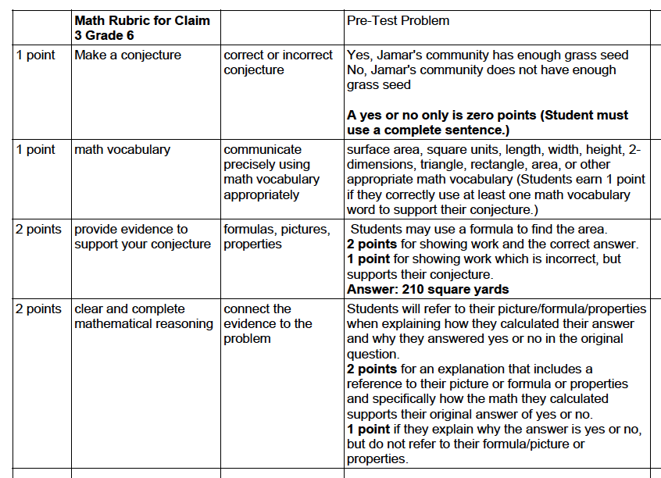

Item Production Information

Item Writer Name |  | Date | 10.13.2019 & 1/8/2020
Team Leader
Editor | Ed Roeber
Discipline | Mathematics
Item Type & Number (PT or PE) | PE | Performance Expectation(s)
Number of SRs | 0
Number of CRs | 3
Number of Graphics | 0
Grade(s) | 6
Copyrighted Material and Sources (Be Specific)

None

Team Leader Comments

Editor Comments

