ELA Assessment
Michigan Department of Education

English Language Arts
Performance Assessment

Performance Event E2.02

Passage-Based Writing

Grade 3

Teacher Booklet
Teacher Directions
Student Directions
Student Essay
Teacher Scoring Rubric

Acknowledgements
Sampler material used with permission of the South Carolina Department of Education. The anchor set displayed with this sampler was developed from the field test items administered in October 2017. This sampler was downloaded from the Michigan Department of Education’s OEAA webpage.

© 2019 by the Michigan Department of Education
[Creative Commons license should be sought so that Michigan educators have permission to reproduce these materials but ownership is retained by the MDE.]

Michigan ELA Standards Assessed
Content Standard
Performance Expectation(s)
Intended Students | This performance assessment may be used with students in third and fourth grade.

Overview and Outline of the Performance ASSESSMENT
Students will be asked to read a passage and then compose (write) a response to a specific prompt about the reading passage. Students are to support their draft text with their opinions through references from the passage. Prewriting, drafting, and revising might be involved. Optionally, students could compose their responses using online assessment software.

Suggested Total Time
This assessment should take a total of 40 minutes to complete, in one part, as shown below.

- Part 1 – Read a Passage and Compose a Response to a Prompt (40 minutes)

List of Required Materials
The following materials are required for this assessment:

  - Student Booklet
  - Blank paper
  - Pens or pencils for writing responses
  - Optional: computers and computer software for computer-based testing.

Assessment SetUp
The teacher should ensure that students have blank paper (for note taking) and pens or pencils for composing their responses after reading the passage. If optional online assessment software is to be used, the teacher should conduct standard preparation, registration, etc. for computer-based testing.

Detailed Script with Teacher and Student Directions
Directions for teachers are in regular text. Directions to be read to students are in bold.

Students need a Student Booklet, blank paper, and a pen or pencil to use write their compositions. When ready to begin, say:

You each should have a Student Booklet. Begin by filling in the information requested on the front cover.

Pause while students complete the requested information. Then say:

Turn to page 2 in your Booklets and read the directions silently as I read them aloud to you.

Pause while students turn to page 2. Then say:

This assessment has one part to it:

- Part 1 – Read a Passage and Compose a Response to a Prompt (40 minutes)

The directions for it are given in the Student Booklet.

PART 1 – READ A PASSAGE AND COMPOSE A RESPONSE TO A PROMPT (40 MINUTES)
The teacher should ensure that students have blank paper (for note-taking) and a pen or pencil available for use in student note taking.

When ready to begin, say:

You will read a passage and then write a response to a prompt about the passage.

Steps You Will be Following
In order to plan and compose your essay, you will do each of the following:

- Read the passage
- Take notes on the passage so you can prepare and write your response to the prompt
- Plan and write your essay

Directions

Now, read the passage found on pages X-Y in your Student Booklet. You will be asked to respond to this prompt after you have read the passage:

The bird is important to the story. Write an essay explaining how the rhinoceros changes because of the actions of the bird. Use evidence from the passage to support your response. You may reference the passage as often as you need.

Remember, a well-written essay:

- shows understanding of the text.
- uses details from the text for support.
- Is organized with an introduction and conclusion.
- Uses transitions and clear language.
- Follows rules of spelling, punctuation, and grammar

The Teacher Scoring Rubric that will be used to evaluate your composition is shown on page Z of your Student Booklet. Please turn to that page a spend a few minutes looking at how your composition will be evaluated.

Teacher Scoring Rubric

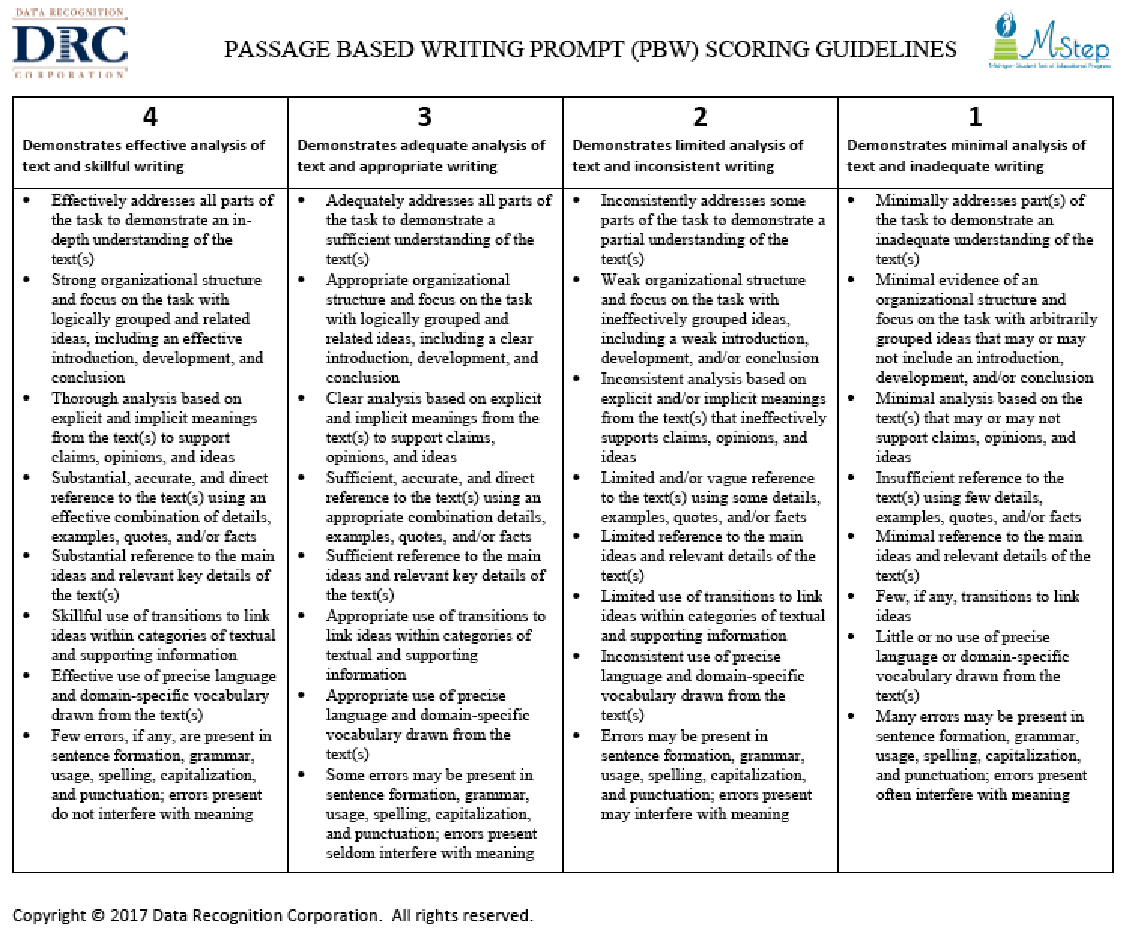

Part 1 – Passage
This passage is found on pages X-Y in the Student Booklet.

The Rhinoceros and the Bird

The rhinoceros was the grumpiest animal in all of Africa. He was always in a horrible mood. He stamped his feet, charged at any animal that passed by, and frightened all animals with his long, pointed horn. He seemed to almost enjoy throwing his weight around. He was so unpleasant and mean, none of the other animals would have anything to do with him. Because of this, he was also very lonely. That made him even grumpier.
One day, the rhinoceros stood alone snorting and grumbling to himself under a ginkgo tree. He noticed a little bird perched cheerfully on a branch above him.
“Hello down there,” chirped the bird.
“Go away and leave me alone!” huffed the rhinoceros.
“I would like to ask you a question,” the bird insisted.
The rhinoceros was so surprised that the bird was still speaking to him, he forgot to be grumpy. “Aren’t you afraid of me?” asked the rhinoceros.
“Not at all,” answered the bird. He was safely out of reach of the rhinoceros. Besides, the bird was too curious to be afraid.
“I was just wondering,” continued the bird, “what in the world makes you so grumpy? You must know that’s why you have no friends.”
The rhinoceros stamped impatiently. “I know. I can’t help it,” he snapped. “You would feel bothered too, if your back were always as itchy as mine.
”The bird looked down at the rhinoceros’s back. “I see your problem!” tweeted the bird, as he hopped excitedly on his branch. “You have little bugs crawling all over your back.”
“Well, now I know the reason,” the rhinoceros shook his head. “But it still doesn’t solve anything.
”The little bird fluttered down to a lower branch to look more closely. “I think I can help you,” said the bird.
“You?” The rhinoceros laughed. “How?
”The bird replied, “You are itchy, and I am hungry. Those bugs look delicious. If you will let me ride along on your back, I will get rid of those unwelcome visitors for you.”
The rhinoceros thought about this. “Won’t I look foolish walking around with a little bird on my back?” he worried.
“Some might say you look pretty foolish now,” reasoned. the bird, “standing here grumbling to yourself under a tree.
”The rhinoceros could not argue with the bird’s point. He agreed, and the little bird hopped onto his back.
The next day, the other animals saw an amazing sight. The rhinoceros was trotting across the plain with a tiny bird perched on his wrinkled shoulder. The rhinoceros felt so much better without the bugs on his back. He felt so good that he did not mind the strange looks he got from the others. His itch and his loneliness were both gone.
Even today, in Africa, you can still see little birds riding on the back of a rhinoceros.

Part 2 – Writing PrompT
This page is found on pages X-Y in the Student Booklet. Response space is condensed in the Teacher Booklet.

The bird is important to the story. Write an essay explaining how the rhinoceros changes because of the actions of the bird. Use evidence from the passage to support your response. You may reference the passage as often as you need.

Remember, a well-written essay:

- shows understanding of the text.
- uses details from the text for support.
- Is organized with an introduction and conclusion.
- Uses transitions and clear language.
- Follows rules of spelling, punctuation, and grammar

The Teacher Scoring Rubric that will be used to evaluate your composition is shown on page Z of your Student Booklet.

_____________________________________________________________________________________
_____________________________________________________________________________________
_____________________________________________________________________________________
_____________________________________________________________________________________
_____________________________________________________________________________________
_____________________________________________________________________________________
_____________________________________________________________________________________
_____________________________________________________________________________________
_____________________________________________________________________________________
_____________________________________________________________________________________
_____________________________________________________________________________________
_____________________________________________________________________________________
_____________________________________________________________________________________
_____________________________________________________________________________________
_____________________________________________________________________________________
_____________________________________________________________________________________
_____________________________________________________________________________________
_____________________________________________________________________________________
_____________________________________________________________________________________
Item Production Information

Item Writer Name | SC Dept of Educ. | Date | 11.2.19
Team Leader
Editor | Ed Roeber
Discipline | ELA
Item Type & Number (PT or PE) | PE | Performance Expectation(s)
Number of SRs | 0
Number of CRs | 1
Number of Graphics | 0
Grade(s) | 3
Copyrighted Material and Sources (Be Specific)

Sampler material used with permission of the South Carolina Department of Education. The grade 3 anchor set displayed with this sampler was developed from the field test items administered in October 2017. This sampler was downloaded from the Michigan Department of Education’s OEAA webpage.

Passage-Based Writing Prompt Scoring Guidelines © Data Recognition Corporation, 2017.

Team Leader Comments

Editor Comments

