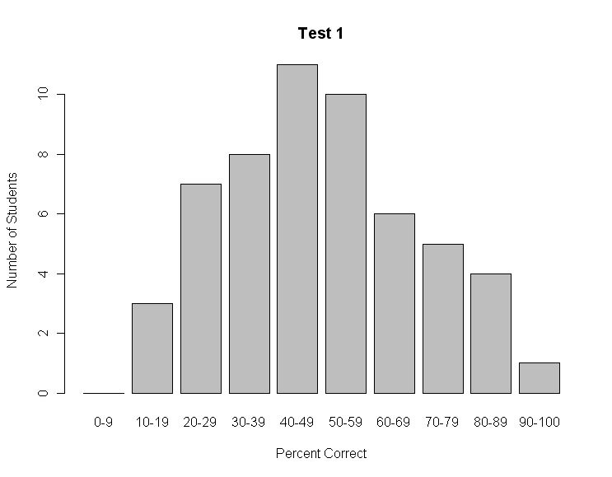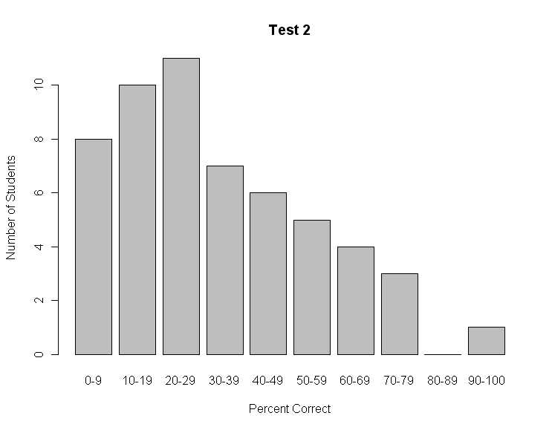

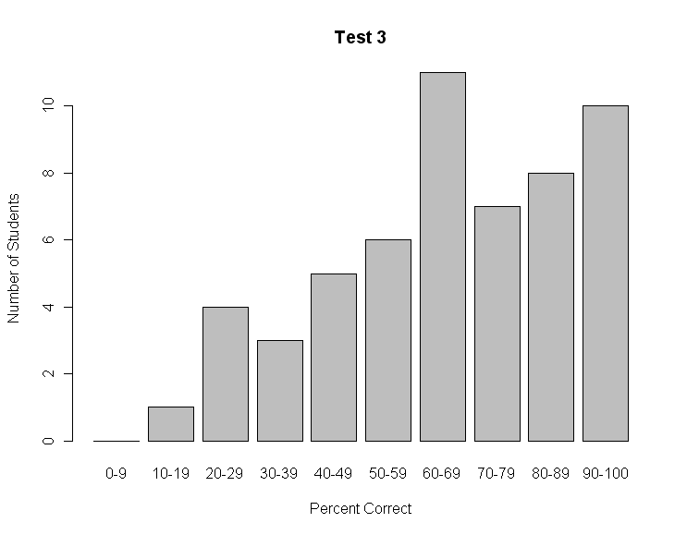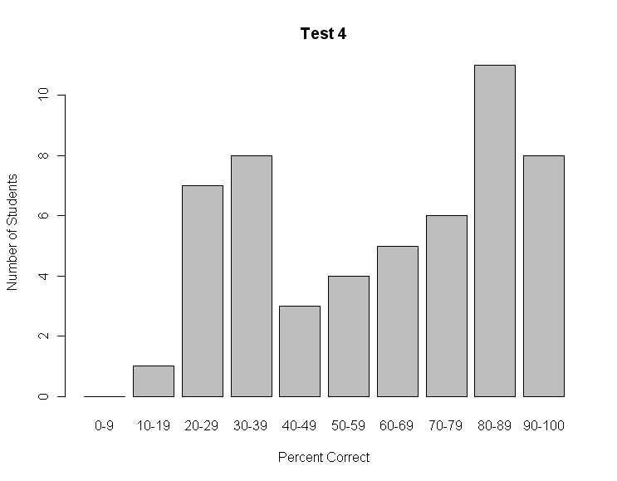

At your table, look at each frequency distribution, above.

1. Classify each test as easy or hard
2. For each distribution what type(s) of test would you expect to see that data shape? Which would you not?
3. What aspects of the data might need further investigation?

Below are the item response patterns for a six-item, multiple-choice test.

|  |  |  |  |  |  |  |  |  |
| --- | --- | --- | --- | --- | --- | --- | --- | --- |
| Item # | A | B | C | D | Omit | Mult | Difficulty | Disc. |
| 1 | 84* | 3 | 4 | 8 | 1 | 0 | 84 | .12 |
| 2 | 23 | 27* | 24 | 26 | 0 | 0 | 27 | .21 |
| 3 | 27 | 1 | 0 | 70* | 2 | 0 | 70 | .59 |
| 4 | 12 | 54* | 13 | 21 | 0 | 0 | 54 | -.08 |
| 5 | 14 | 10 | 61 | 15* | 0 | 0 | 15 | .61 |
| 6 | 2 | 3 | 63* | 3 | 29 | 0 | 63 | .71 |

Based on the data provided, are there any items on this test that need to be reviewed?